**FRIO COUNTY COMMISSIONERS COURT MINUTES FOR**

**Regular Meeting April 25th, 2023**

On the 25th day of April, 2023, at 3:00 p.m., the Commissioners Court of Frio County met in a regular meeting with the following members either absent or present, to-wit: Rochelle Lozano Camacho, Frio County Judge was present; Joe Vela, Commissioner Pct 1 present; Mario Martinez, Commissioner Pct 2 present; Raul Carrizales, Commissioner Pct 3 present; Danny Cano, Commissioner Pct 4 present; Joseph A. Sindon, Legal Counsel for Frio County Commissioners Court present; and Aaron Ibarra, Frio County Clerk present when the following meeting was held, to-wit:

I. Invocation and Pledge of Allegiance

II. Adopt Agenda

**MOTION: COMMISSIONER CARRIZALES**

**SECOND: COMMISSIONER MARTINEZ**

**MOTION PASSED**

III. Old Business

**PRESENTATION**

**ACTION AGENDA ITEMS**

IV. General Discussion-**none**

V. Citizens To Be Heard -**none**

VI. New Business

**PRESENTATION**

(1) Ronald Rocha, Attorney at Law, Linebarger Goggan Blair & Sampson, LLP**,** requests:

Update on the delinquent fines and collection services by Linebarger Goggan Blair & Sampson LLP.

**Item presented, no other discussions occurred.**

(2) Hon. Raul Carrizales, III. Frio County Commissioner, Precinct No. 3, requests:

Presentation of monthly statistics reports compiled by ShureMed.

**ITEM PRESENTED, NO OTHER ITEMS WERE DISCUSSED.**

**ACTION AGENDA ITEMS**

(1)  Hon. Rochelle Camacho, Frio County Judge, requests:

* 1. Consider/take action on initiating an interlocal agreement with El Sacrificio, a non-profit in Pearsall Tx, for providing a Frio County Emergency shelter located on North Peach Street.
  2. If there is approval in pursuing this agreement consider/take action on approving a motion authorizing Hon. Rochelle Camacho, Frio County Judge in working with non-profit executive director, Mr. Reynaldo M. Trevino and county staff in preparing a final interlocal agreement which will be presented to court within 30 days.

**NO ACTION TAKEN**

(2)  Hon. Rochelle Camacho, Frio County Judge, requests:

2.1 Consider/take action on constructing/installing a Frio County COVID Memorial monument slab on the north entrance of the court house.

2.2 If there is approval in pursuing this agreement consider/take action on approving a motion authorizing Hon. Rochelle Camacho, Frio County Judge in working with non-profit executive director, Mr. Reynaldo M. Trevino and county staff in preparing a final budget and project timeline for memorial which will be presented to court within 30 days.

**NO ACTION TAKEN**

(3) Hon. Rochelle Camacho, Frio County Judge, requests:

3.1 Consider/take action on finding that circumstances present in all or part of the unincorporated areas of Frio County that create a public safety hazard that would be exacerbated by outdoor burning.

3.2 Consider/take action on adopting an Order of the Frio County Commissioners Court Prohibiting or Restricting Outdoor Burning in the Unincorporated Areas of Frio County, Texas from May 4, 2023 to August 2, 2023.

**NO ACTION TAKEN**

(4) Ancelmo Ornelas, Frio County Road and Bridge Administrator, requests:

4.1 Consider/take action on approving and adopting resolutions granting permits to Pilot Water Solutions, SDW LLC to lay bore, construct and maintain one (1) eight inch (8”) polypropylene pipe water line enclosed in a one (1) twelve inch (12”) steel casing under the County Road 4850 Road right-of-way for a total permit fee of $150.00.

4.2 If the resolution is approved and adopted, then authorize Frio County Judge Rochelle Camacho to execute the permit on behalf of Frio County, Texas to Pilot Water Solutions, SDW LLC.

**NO ACTION TAKEN**

(5) Hon. Mike Morse, Frio County Sheriff, requests:

Consider/take action on approving and adopting a resolution approving the grant application to Frio County for participation in Operation Stonegarden.

**MOTION: COMMISSIONER CARRIZALES**

**SECOND: COMMISSIONER MARTINEZ**

**MOTION PASSED**

(6) Hon. Mike Morse, Frio County Sheriff, requests:

6.1 Consider / take action on approving a 2023 Summer Earn & Learn Worksite Agreement between Frio County and Workforce Solutions Alamo.

6.2 If the Agreement is approved, consider/take action on approving a resolution authorizing Hon. Rochelle Camacho, Frio County Judge, to sign same on behalf of Frio County.

**MOTION: COMMISSIONER CARRIZALES**

**SECOND: COMMISSIONER MARTINEZ**

**MOTION PASSED**

(7) Hon. Mike Morse, Frio County Sheriff, requests:

Consider / take action on running a sealed request for qualifications (RFQ) ad (below) in the Frio Nueces Current once a week for two weeks pursuant to Local Government Code Sec. 262.025.  The ad will run in the Frio-Nueces Current on May 4, 2023 and on May 11, 2023.  Sealed RFQ’s will be accepted in the Sheriff’s Department office until 3:00 pm, May 26, 2023.  RFP’s will be opened during commissioner’s court on May 30, 2023.

**REQUEST FOR QUALIFICATIONS**

By order of the Commissioner’s Court of Frio County, Texas, and pursuant to Section 262.023 of the Texas Local Government Code, the County is accepting qualifications for design/build services to assist the County with building renovation and evaluate energy consumption. Qualifications will be received at the Frio County Sheriff’s Office located at 502 S. Cedar Street, Pearsall, Texas 78061 until **3:00 P.M., May 26, 2023**. Qualifications received after the time indicated will be returned unopened. Prospective firms may contact Chief Deputy Sheriff Peter Salinas by e-mail at [psalinas@friosheriff.org](mailto:psalinas@friosheriff.org) in regards to obtaining the RFQ documents. An appointment to discuss the RFQ may be scheduled by contacting Mr. Salinas. Frio County reserves the right to reject any and all RFQs. Frio County is an Affirmative Action/Equal Opportunity Employer. For more information, visit <http://www.co.frio.tx.us/>.

**MOTION: COMMISSIONER CARRIZALES**

**SECOND: COMMISSIONER MARTINEZ**

**MOTION PASSED**

(8) Hon. Crystal Marquez, Frio County Auditor, requests:

Consider / take action on approving one-time payment of $1,053.34 for construction cost and a security light for IH-35 and CR 4602 in the Hilltop Subdivision in Dilley, Texas.

**MOTION: COMMISSIONER CANO**

**SECOND: COMMISSIONER CARRIZALES**

**MOTION PASSED**

(9) Hon. Crystal Marquez, Frio County Auditor, requests:

Consider / take action on approving one-time payment of $1,454.97 for construction cost and a security light for CR 4603 and CR 4604 in the Hilltop Subdivision in Dilley, Texas.

**MOTION: COMMISSIONER CANO**

**SECOND: COMMISSIONER MARTINEZ**

**MOTION PASSED**

(10) Hon. Crystal Marquez, Frio County Auditor, requests:

Consider / take action on approving Quote for Spectrum Services with Spectrum Enterprise for telephone and internet services for the location of 407 S. Pecan St, Pearsall, TX for an estimated monthly cost of $280.98 per month, including an estimated $599.00 one-time installation charge.

**MOTION: COMMISSIONER CARRIZALES**

**SECOND: COMMISSIONER CANO**

**MOTION PASSED**

(11) Hon. Crystal Marquez, Frio County Auditor, requests:

11.1 Consider / take action to approve the budget amendments to the FISCAL YEAR 2022-2023 Frio County Budget, list below:

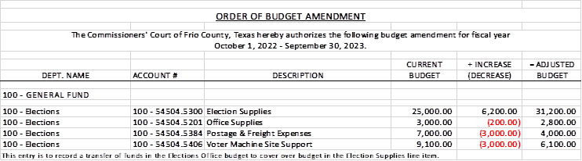

11.2 If the amendment is approved, consider/take action on signing order stating same.

**MOTION: COMMISSIONER MARTINEZ**

**SECOND: COMMISSIONER CARRIZALES**

**MOTION PASSED**

(12) Hon. Crystal Marquez, Frio County Auditor, requests:

12.1 Consider / take action to approve the budget amendments to the FISCAL YEAR 2022-2023 Frio County Budget, list below:

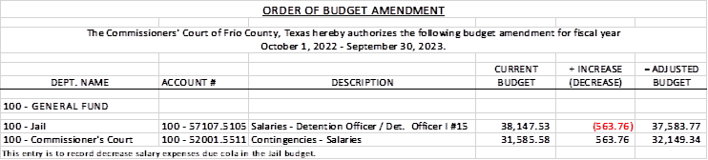

12.2 If the amendment is approved, consider/take action on signing order stating same.

**MOTION: COMMISSIONER MARTINEZ**

**SECOND: COMMISSIONER CANO**

**MOTION PASSED**

(13) Hon. Crystal Marquez, Frio County Auditor, requests:

13.1 Consider / take action to approve the budget amendments to the FISCAL YEAR 2022-2023 Frio County Budget, list below:

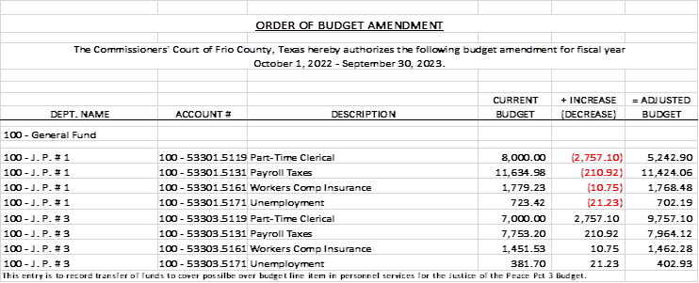

13.2 If the amendment is approved, consider/take action on signing order stating same.

**MOTION: COMMISSIONER MARTINEZ**

**SECOND: COMMISSIONER CANO**

**MOTION PASSED**

(14) Hon. Crystal Marquez, Frio County Auditor, requests:

14.1 Consider / take action on approving Service Order with Spectrum Enterprise for Spectrum Business Services for a total cost of $231.91 per month, including a $297.00 one-time installation charge for the DPS Highway Patrol Office, Frio County Elections Office, Veterans Office, Road and Bridge Pearsall Office, Justice of the Peace Precinct # 4, and the Frio County Tax Office Dilley Extension.

14.2 If the Service Order is approved, consider/take action on approving a resolution authorizing Hon. Rochelle Camacho, Frio County Judge, to sign same on behalf of Frio County.

**MOTION: COMMISSIONER CARRIZALES**

**SECOND: COMMISSIONER CANO**

**MOTION PASSED**

(15) Hon. Crystal Marquez, Frio County Auditor, requests:

15.1 Consider / take action on approving online credit application with Door Control Services.

15.2 If the application is approved, then approve and sign a resolution authorizing Hon. Rochelle Camacho, Frio County Judge to execute the application on behalf of Frio County.

**MOTION: COMMISSIONER CARRIZALES**

**SECOND: COMMISSIONER MARTINEZ**

**MOTION PASSED**

(16) Hon. Raul Carrizales, III, Frio County Commissioner, Precinct No. 3, requests:

Consider/take action on approving the construction of 6 new safety lights in continuation of Pct. 3 safety light project.  2 lights on CR1000, 1 light on CR 1151 and 3 lights on CR 1001.

**MOTION: COMMISSIONER CANO**

**SECOND: COMMISSIONER CARRIZALES**

**MOTION PASSED**

(17) Hon. Raul Carrizales, III, Frio County Commissioner, Precinct No. 3, requests:

Consider/take action on the purchase and installation of 2 "Caution Autistic Child in Area" signs, to be placed on CR 1056 Horizon Dr.

**MOTION: COMMISSIONER CARRIZALES**

**SECOND: COMMISSIONER MARTINEZ**

**MOTION PASSED**

(18) Hon. Rochelle Camacho, Frio County Judge, requests

18.1 Public hearing regarding Community Development Grant application being submitted to the Texas Department of Agriculture 

18.2   Discuss, consider, and take action to approve a Resolution authorizing the submittal of Community Development Grant application to the Texas Department of Agriculture.

**MOTION: COMMISSIONER MARTINEZ**

**SECOND: COMMISSIONER CARRIZALES**

**MOTION PASSED**

18.3    Discuss, consider, and take action to authorize Judge Rochelle Lozano Camacho to sign all related documents pertaining to the Community Development Grant application to the Texas Department of Agriculture.

**MOTION TO ENTER EXECUTIVE SESSION AT 4:19 P.M.**

**MOTION: COMMISSIONER CARRIZALES**

**SECOND: COMMISSIONER MARTINEZ**

**MOTION PASSED**

**MOTION TO RETURN FROM EXECUTIVE SESSION AT 4:42 P.M.**

**MOTION: COMMISSIONER CARRIZALES**

**SECOND: COMMISSIONER CANO**

**MOTION PASSED**

18.4 Discuss, consider, and take action to solicit RFQ's for the TDA Community Grant.

**MOTION: COMMISSIONER MARTINEZ**

**SECOND: COMMISSIONER CANO**

**MOTION PASSED**

18.5 Discuss, consider, and take action to solicit RFP's for the TDA Community Grant.

**MOTION: COMMISSIONER CARRIZALES**

**SECOND: COMMISSIONER MARTINEZ**

**MOTION PASSED**

18.6 Discuss, consider, and take action to allow Lone Star Strategy Group, LLC to apply for the COPS Hiring Program (CHP).

**MOTION: COMMISSIONER MARTINEZ**

**SECOND: COMMISSIONER CANO**

**MOTION PASSED**

(19) Hon. Rochelle Camacho, Frio County Judge, requests

19.1 Consider/take action convening in executive session pursuant to Texas Government Code Section 551.074, Deliberating about personnel matters to discuss the possible advertising and hiring process of a new Frio County Engineer.

19.2 Consider/take action on extending the deadline for applications for a new Frio County Engineer.

(20) Hon. Joe Vela, Frio County Commissioner. Precinct No. 1, requests:

Consider/take action on approving the county to pay Primrose Funeral Chapels for the indigent cremation for Katherine Bueno.

**NO ACTION**

(21) Hon. Mario Martinez, Frio County Commissioner. Precinct No. 2, requests:

21.1 Consider/take action on the installation of three (3) safety street lights on County Road 2000 aka Sand Hollow Road.

**MOTION: COMMISSIONER CARRIZALES**

**SECOND: COMMISSIONER CANO**

**MOTION PASSED**

21.2 Consider/take action on the installation of two (2) safety street lights off of FM 2079 aka Berry Ranch Road.

**MOTION: COMMISSIONER MARTINEZ**

**SECOND: COMMISSIONER VELA**

**MOTION PASSED**

(22) Documents (resolutions, orders, contracts, etc.) to be signed.

**REVIEWED AND SIGNED**

(23) Allow bills payable

**MOTION: COMMISSIONER CARRIZALES**

**SECOND: COMMISSIONER CANO**

**MOTION PASSED**

(24) Adjourn

**MOTION: COMMISSIONER CARRIZALES**

**SECOND: COMMISSIONER CANO**

**MOTION PASSED**

**APPROVED:**

**_____________________________________  
  
_____________________________________  
  
_____________________________________  
  
_____________________________________  
  
_____________________________________**